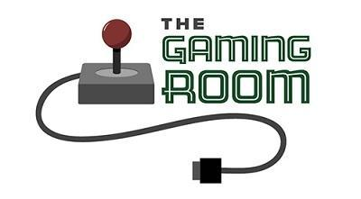

Draw It or Lose It Web Application

CS 230 Project Software Design Template
Version 1.0

Table of Contents

CS 230 Project Software Design Template 1
Table of Contents 2
Document Revision History 2
Executive Summary 3
Requirements 3
Design Constraints 3
System Architecture View 3
Domain Model 3
Evaluation 4
Recommendations 5

Document Revision History

Version | Date | Author | Comments
1.0 | 05/24/2026 | Gabrielle Francis | Initial software design document submission

Instructions
Fill in all bracketed information on page one (the cover page), in the Document Revision History table, and below each header. Under each header, remove the bracketed prompt and write your own paragraph response covering the indicated information.

Executive Summary

The Gaming Room wants to expand its current Android game, Draw It or Lose It, into a web-based application that can be used across multiple platforms. Since the current version only works on Android devices, moving to a web-based design would make the game more accessible to users on desktops, laptops, and mobile devices using different operating systems.
To support this transition, the software needs to be designed in a way that is organized, scalable, and easy to maintain. Using object-oriented programming principles will help keep the code efficient by reducing repetition and organizing shared features between different classes. Design patterns such as Singleton and Iterator will also help meet the client’s requirements by controlling how objects are created and making it easier to search for existing game data.
A web-based distributed design is a practical solution because it allows the core game logic to be managed centrally while users connect from different devices. This approach will make future updates easier and allow the application to grow as more users begin using the platform.

Requirements

The client wants the existing Android version of Draw It or Lose It converted into a web-based application that can support multiple operating systems and devices. The application needs to allow one or more teams to participate in a game, and each team should be able to include multiple players.
The software must make sure that each game, team, and player has a unique identifier so objects can be tracked properly. Game and team names also need to be unique so users cannot accidentally create duplicates.
The system should be designed in a way that supports future expansion, remains efficient, and can be maintained easily as the application grows.

Design Constraints

One major design constraint is the requirement to support multiple platforms in a web-based environment. Because the game will need to work across different devices and operating systems, the design must remain platform-independent instead of relying on software built for only one operating system.
Another constraint is the requirement that only one instance of the game service exists in memory at a time. This means the application needs a design that prevents duplicate service objects from being created, which is why the Singleton pattern is useful here.
The software also needs to make sure that game names, team names, and player names remain unique. This adds extra checks during object creation since the system must search existing data before allowing a new object to be created.
Since this application will run in a distributed environment, factors like internet connectivity, server performance, and security also need to be considered. The application must remain reliable while protecting user data across multiple platforms.

System Architecture View

The Draw It or Lose It application will use a web-based distributed architecture where the main application runs on a server and users connect through client devices such as computers, tablets, or smartphones. This setup allows the application to be accessed from multiple platforms without needing separate versions for each operating system.
Keeping the main game logic on the server also makes updates easier since changes only need to be made in one place instead of on every device. This design also improves scalability if the number of users increases over time.

Domain Model

The UML diagram shows an object-oriented design where several classes work together to represent the game structure. The Entity class acts as a parent class that stores shared attributes like an ID and a name. The Game, Team, and Player classes inherit from this parent class, which helps reduce repeated code and makes the design easier to maintain.
The Game class represents a single game and contains teams, while the Team class contains players. This creates a structure that matches how the actual game works in real life.
The GameService class manages the creation and organization of game objects. It uses the Singleton design pattern to make sure only one instance of the service exists, which matches the client’s requirement. The Iterator pattern is used when checking existing collections to make sure duplicate names are not created.
This design demonstrates inheritance, encapsulation, and abstraction, all of which help make the application more organized and easier to expand later.

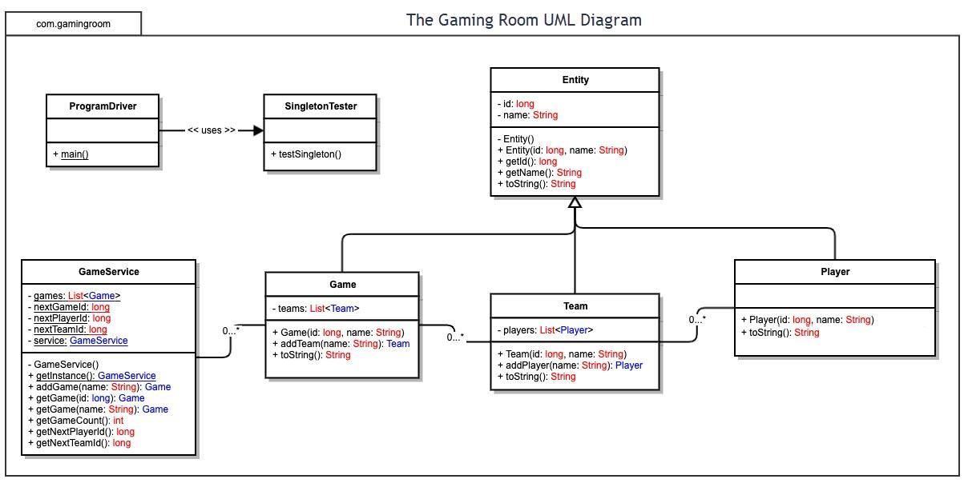

Evaluation

Using your experience to evaluate the characteristics, advantages, and weaknesses of each operating platform (Linux, Mac, and Windows) as well as mobile devices, consider the requirements outlined below and articulate your findings for each. As you complete the table, keep in mind your client’s requirements and look at the situation holistically, as it all has to work together.

In each cell, remove the bracketed prompt and write your own paragraph response covering the indicated information.

Development Requirements | Mac | Linux | Windows | Mobile Devices
Server Side | MacOS can be used to host a web application, but it is not the best choice for a production environment. Apple hardware is expensive and not commonly used for large-scale web hosting. While macOS is stable and secure, it does not offer the same level of scalability and cost efficiency as Linux servers. Licensing costs are tied to Apple hardware requirements. | Linux is the strongest option for hosting the Draw It or Lose It web application. It is widely used for web servers because it is reliable, secure, scalable, and supports technologies such as Apache, Nginx, Java, and MySQL. Most Linux distributions are open source, which minimizes licensing costs and makes Linux a cost-effective solution for The Gaming Room. | Windows Server is capable of hosting large web applications and integrates well with Microsoft technologies. However, it typically requires server licenses and additional licensing costs that increase overall expenses. While it is user-friendly and familiar to many organizations, it generally requires more resources than Linux and can be more expensive to maintain. | Mobile devices are not designed to function as web servers for large numbers of users. Smartphones and tablets should be used only as client devices that connect to the hosted application. Therefore, mobile platforms are not appropriate for server-side deployment.
Client Side | MacOS users can access the application through modern web browsers such as Safari, Chrome, and Firefox. Since the game will be web-based, a separate macOS application is not required. Browser testing will be necessary to ensure consistent functionality across all supported browsers. | Linux users can access the application through standards-compliant web browsers. Because Linux distributions vary, additional browser and configuration testing may be necessary. However, the web-based approach eliminates the need to develop a separate Linux version of the software. | Windows is the most widely used desktop operating system and will likely represent a large portion of users. The application can run through modern browsers such as Chrome, Edge, and Firefox. Developers must ensure compatibility across multiple browsers and screen resolutions to provide a consistent user experience. | Mobile support is essential because many users will access the game through smartphones and tablets. The application should use responsive web design techniques so it functions correctly on both Android and iOS devices. Testing must be performed on multiple screen sizes, browsers, and operating systems to ensure compatibility and usability.
Development Tools | MacOS supports development tools such as Eclipse, IntelliJ IDEA, Visual Studio Code, Java SDK, Git, and browser testing tools. It is particularly valuable when testing applications for iOS devices. The primary disadvantage is the higher cost of Apple hardware. | Linux supports a wide range of free and open-source development tools including Eclipse, IntelliJ IDEA, VS Code, Git, Docker, Java SDK, and database management systems. Most tools have little or no licensing cost, making Linux a cost-effective development platform. | Windows supports the same major development tools as Linux and macOS. Visual Studio provides additional enterprise-level development features. While Windows is familiar to many developers, some advanced Microsoft development tools may require licensing fees. | Mobile devices are not practical for software development but are important for application testing. Developers must verify that the responsive web interface functions correctly on Android and iOS devices. Testing may require access to multiple physical devices or mobile emulators. Multiple team members may be needed to perform browser, device, and usability testing across different platforms. .

Recommendations

Analyze the characteristics of and techniques specific to various systems architectures and make a recommendation to The Gaming Room. Specifically, address the following:

- Operating Platform: For this project, I would recommend Linux as the server operating system. Linux is commonly used for web applications because it is reliable, handles multiple users well, and doesn't have the same licensing costs as Windows. Since The Gaming Room wants Draw It or Lose It to support users on different devices and platforms, Linux would be a practical and cost-effective choice.

- Operating Systems Architectures: Linux is built to support multiple users and processes at the same time, which is important for a game like Draw It or Lose It where several games could be running at once. It also works well in a client-server setup. The server would handle the game itself while users connect through a web browser on their computers, tablets, or phones. This makes updates easier because changes only need to be made on the server instead of every device.

- Storage Management: For storing data, I would recommend using a database management system like MySQL. The database could store player information, team names, scores, and game records. The image files used in the game could be stored separately on the server while the database keeps track of where they are located. This would help keep everything organized and make it easier to add more content in the future if the game grows.

- Memory Management: Memory management is important because the game needs to load images quickly without slowing down. Instead of loading the entire image library into memory, the application should only load the images needed for the current game. Linux does a good job managing memory and freeing up resources that are no longer being used. This helps keep the application running smoothly, especially when multiple users are connected at the same time.

- Distributed Systems and Networks: A distributed system would allow players on different operating systems to connect to the same game through the internet. The server would contain the game logic and data while users access it through their devices. One thing to consider is that internet connectivity can affect gameplay. If the server goes down or there are network issues, players may not be able to access the game. Because of this, having reliable servers and regular backups would be important.

- Security: Security is something The Gaming Room should take seriously because user information needs to be protected. Using HTTPS would help secure data being sent between users and the server. User accounts should also require authentication so only authorized users can access them. Linux includes several built-in security features, and keeping the system updated with security patches would help reduce risks. Firewalls and other security tools could also be used to help protect the application from outside threats.

